Fossil Cycle Reading
What is a fossil?
Fossils are not just dinosaur bones, but can be any evidence of past life. They can be the bodies of animals and plants that once existed or just traces of those animals. Body fossils include isolated bones, whole skeletons, shells, teeth, leaves and wood. Traces fossils are things like footprints or swimming traces and coprolites (fossil poop!!). Fossils tell us what kinds of animals and plants lived a long, long time ago and can even tell us information about how it lived its life. We can learn about what they ate (and what ate them!) and what kind of environment they lived in.
How are fossils formed?
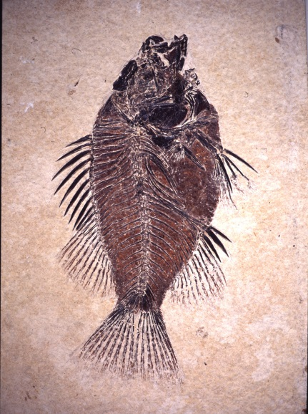
Fossils can form in several ways, but the basic method can be summarized in three steps. 1: the animal or plant must die. Unfortunately organisms do not live forever, and once they are dead they have the opportunity to become a fossil. Not everything that dies becomes a fossil, otherwise we would have dead animals and fossils over our heads!! Some of the dead organisms decompose and are recycled back into the environment. If a dead animal or plant is to become a fossil it must 2: become buried in sediment. Sometimes this happens fast (land/mudslide) and sometimes it happens slow (lake bottom). Not every dead animal or plant that becomes buried in sediment becomes a fossil though. Some are decomposed by bacteria, insects and worms and are recycled throughout the ecosystem. In order to become a fossil, buried animals must be protected from scavengers and decomposers. If they are protected, 3: lots of time has to pass before an animal can become fossilized. The soft parts of the animal usually rot away, leaving the hard bones that react with minerals in groundwater, turning the bones into stone.
What happens to an animal or plant that does not become a fossil?
The majority of animals do not become fossils. It is quite rare that an animal might be fossilized, which makes the fossils we do find very special. Several things may prevent an animal from becoming a fossil. Scavengers may consume the body of dead organisms. This could lead to the complete loss of the animal, or to scattered fossil bones. Some animals and plants rot away in oxygen rich environments where bacteria and fungus thrive. Animals that do not become fossils are still a part of the paleo-environment, and their nutrients are recycled throughout the ecosystem. Other plants and animals benefit from the source of food and nutrients dead animals provide. If every animal and plant became a fossil, there would be no more nutrients to cycle through the environment!
Preservation Bias in the Fossil Record
What is a bias?
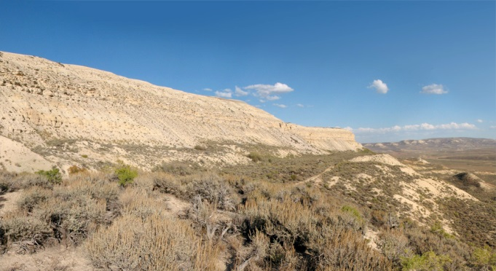
A bias occurs when we make a judgment about something based on our own personal experience. We may favor one state over another because we grew up in one and/or had a bad experience in the other. We may say our favorite mineral is quartz, so we have a bias for quartz when viewing or learning about other minerals. A bias is not always a bad thing, and in science it can help explain why some things occur more often than others
How does this relate to fossils?
Animals themselves do not have a bias, meaning they do not have a preference of becoming a fossil or not. However, the environmental conditions and the physical features of the animal/plant can increase or decrease the chance of an organism becoming a fossil. We call this the preservation bias. Certain environmental conditions (aquatic, low oxygen, quick burial) favor the preservation of organisms. Body features such as hard parts also help with preservation of organisms. Therefore, the fossil record has a bias toward animals that lived in a low oxygen environment and contained hard parts. There are more of them preserved than animals that lived on land and had only soft parts.
There are several biases that can help inform our research of the fossil record. We will discuss three biases that are most evident in the fossil record (and relate to Fossil Lake!)
Land or water? Animals that live in water are more likely to be fossilized because they are more easily buried in sediment.
Hard or soft parts? Organisms with soft parts are rarely preserved because the soft tissue rapidly decomposes. Hard parts such as bones and shells are more readily fossilized.
Observer bias. The paleontologist may favor one type of fossil over another, and looks exclusively for that type of fossil. The other fossils are present but are not collected.
How can we use the preservation bias to learn more about fossils?
In Fossil Lake, we know the depositional environment favored the preservation of aquatic animals like fish. Fish are the most common fossil in Fossil Lake (millions have been found!). We have also found several terrestrial (land) animals such as snakes, lizards and a horse (among others). These fossils are quite rare because they lived on land. But it is safe to assume that during the time of Fossil Lake, many of these animals roamed the shore and were not fossilized after they died. The preservation bias of a fossil location can help us better understand the abundance of ancient animals.

